5/4/2025
Moiz Ansari [23i-0523]
Abdullah Siddiqui [23i-0617]

Hospital - Case Study
DataBase Assignment 3
Team members:
Table of Contents
ERD 2
Relational Schema 3
Modifications 3
Trigger Testing 4
TASK 1 4
TASK 2 5
TASK 3 5
TASK 4 6
TASK 5 6
TASK 6 7
TASK 7 8
Tables Updated 9

ERD
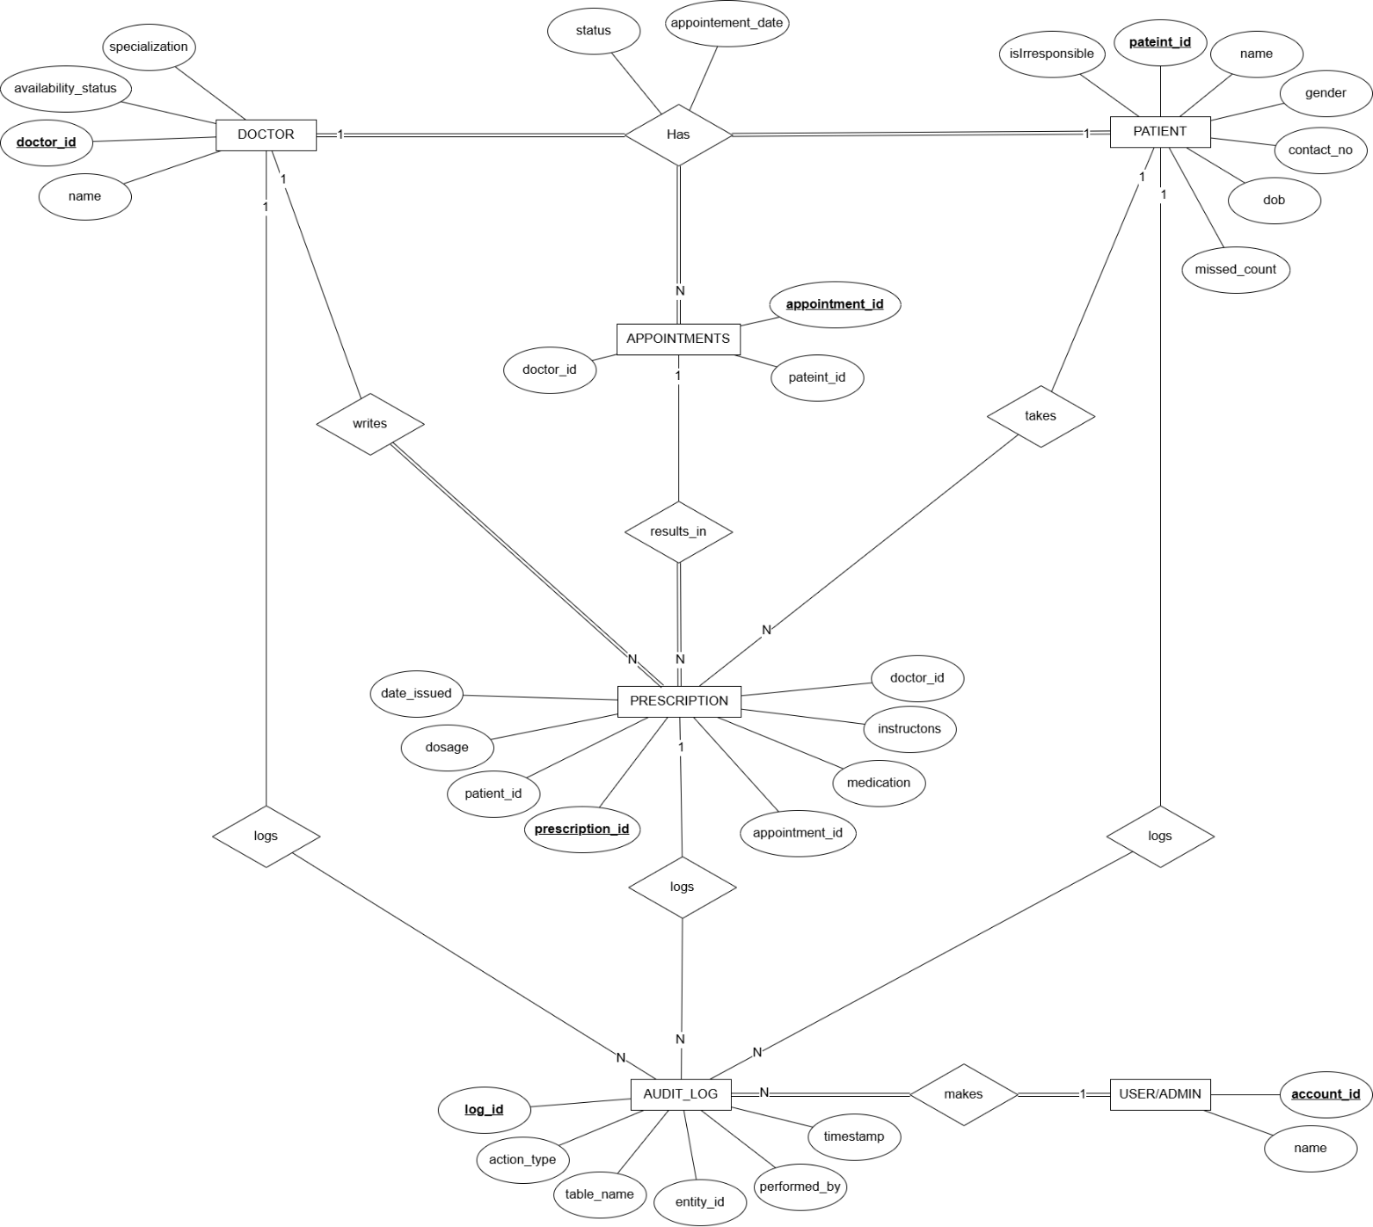

Relational Schema
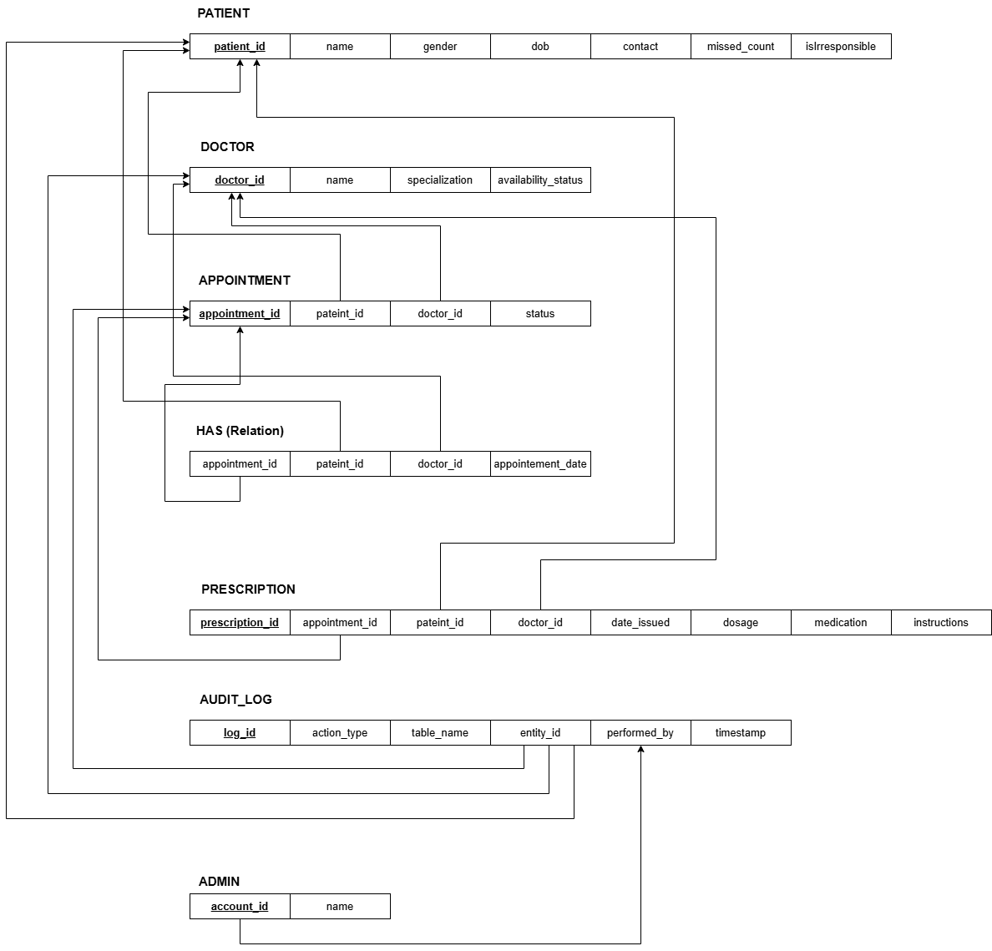

Modifications
- Added columns missed_count and isIrresponsible (flag) in PATIENTS table for missing appointments.
- Used Appointment table as Has(relation) table.
- Made table of Admin and added account_no and names.

Trigger Testing

TASK 1
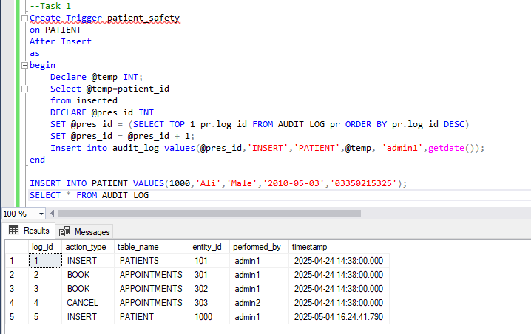
Upon insertion of patient values, Audit Logs following data.

TASK 2
Upon insertion and deletion, audit logs respective message like “BOOK” on insertion and “ CANCEL” on deletion.
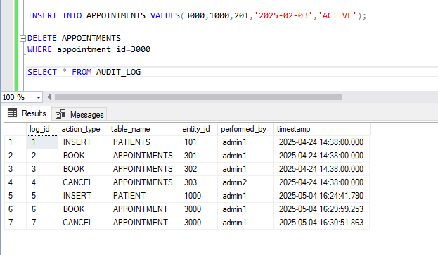

TASK 3
When changing availability from Unavailable to Available, it logs status update data. It would not log if the same status is changed to previous value.
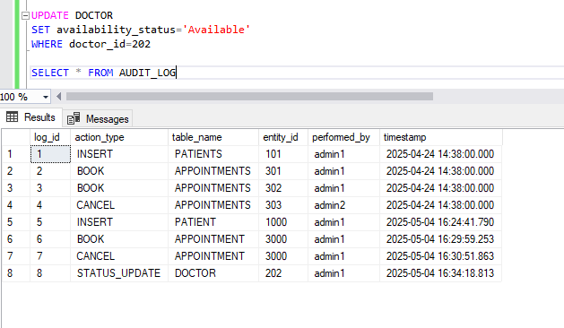

TASK 4
Upon adding an appointment for an unavailable doctor, it stored the rejected insert record. It will do the same if same appointment is done again with already existing appointment date for a patient.
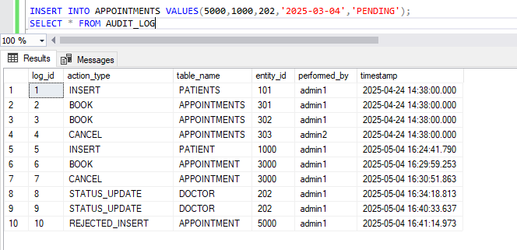

TASK 5
Added prescription
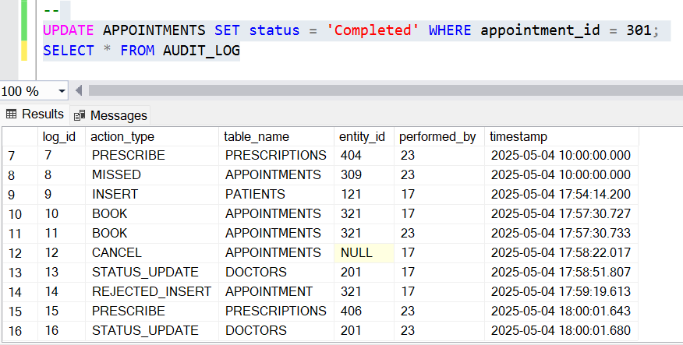
Rejected Prescription
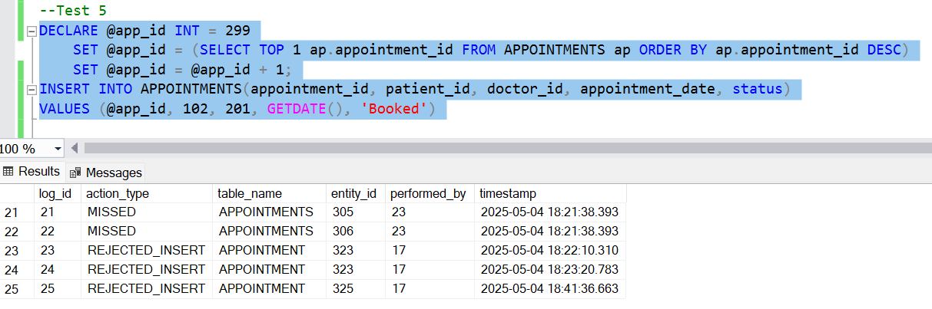

TASK 6
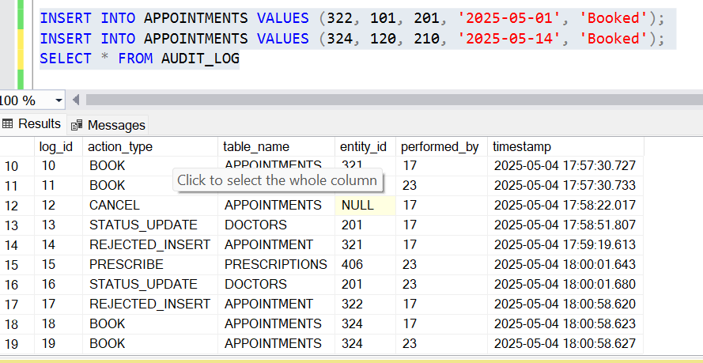

TASK 7
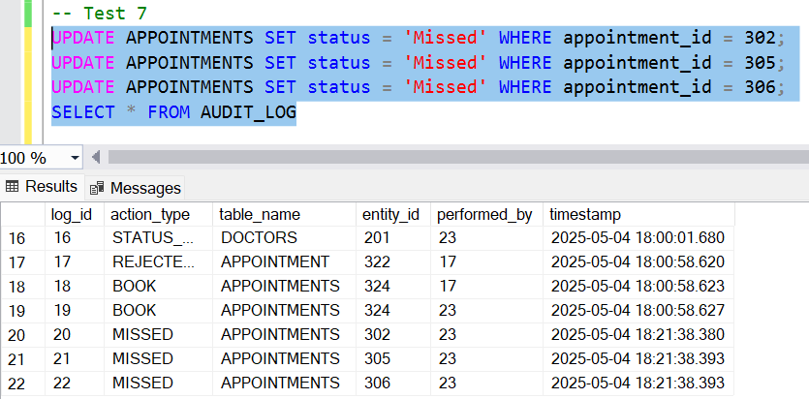
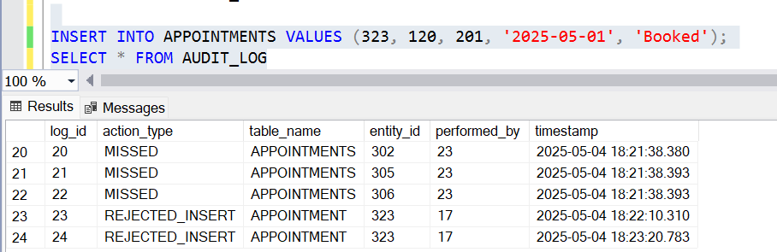
Tables Updated